

**COMPUTER SCIENCE PROJECT**

Session 2021-22

**TOPIC:**

A simple 2 stages quiz using the knowledge of MySQL and python

Submitted By: Submitted To:

Gauransh Goel Mrs. Swati Yadav

**CERTIFICATE**

This is to certify that **Gauransh Goel** of class/sec **12th C** has successfully completed the project on the topic, **Quiz from MySQL and Python** to my satisfaction and submitted the same during the academic year 2021-22. The project is the result of his/her efforts & endeavors.

Signature of Teacher: ____________________

**ACKNOWLEDGEMENT**

It is my privilege to express my most sincere regards to all who directly or indirectly helped me to complete my project work. I, deeply express my sincere thanks to our Computer Science teacher, Mrs. Swati Yadav for her noble guidance & providing sufficient facilities which have contributed to the successful completion of this project. I take this opportunity to thank all my teachers, parents & friends who have helped me with their valuable suggestions, encouragement & guidance that have been very helpful in various phases of the completion of the project.

Gauransh Goel

12th C

(DPS Rajnagar)

**OVERVIEW**

In this project, I, have implemented basic knowledge of MySQL and Python to create a simple 2 stages quiz game. In this game, the user will enter into the game via Stage 1 and clear all the way up to Stage 2. This game is a parody version of KBC, and we have implemented a basic counter system, that will count how much money (virtual money) you have won. There is different amount of virtual money you can earn for different questions. Also, the level of difficulty increases going from Stage 1 to Stage 2. In the end, you will be shown the amount of money you have won. The questions and answers are stored in MySQL database, and the whole program works from Python.

**Coding – MySQL**

create database kbcdb9;

use kbcdb9;

create table stage1(questions varchar(500),options varchar(500));

#Stage 1 questions:

insert into stage1 values("which of the following is not a DDL command","(a)UPDATE (b)TRUNCATE (c)ALTER (d)none of these");

insert into stage1 values("which of the following is not a legal constraint for a CREATE TABLE command","(a)Primary Key (b)Foreign Key (c)unique (d)distinct");

insert into stage1 values("which command is used for removing a table and all of its data from the database","(a)Create table command (b)Drop table command (c)Alter table command (d)all of these");

insert into stage1 values("The data types CHAR(n) and VARCHAR(n) are used to create___ and ___ length types of string/text field in a database.","(a)fixed,equal (b)equal,variable (c)fixed,variable (d)variable,equal");

insert into stage1 values("A____ is a query that retrieves rows more than one table or view","(a)Start (b)End (c)Join (d)all of these");

create table stage2(questions2 varchar(500), options2 varchar(500));

insert into stage2 values("Which operator performs pattern matching","(a)BETWEEN (b)LIKE (c)EXISTS (d)Noneof these");

insert into stage2 values("By Default,ORDER BY clause lists the results in __ order","(a)Descending (b)Any (c)Same (d)Ascending");

insert into stage2 values("Which of the following is a SQL aggregate function","(a)LEFT (b)AVG (c)JOIN (d)LEN");

insert into stage2 values("All aggregate functions except __ ignore null values in their input collection","(a)Count(attribute) (b)Count(*) (c)Avg (d)Sum");

insert into stage2 values("Where and Having clauses can be used interchangeably in SELECT queries ","(a)True (b)False (c)Only in views (d)With Order By");

select * from stage1;

**Coding – Python**

# SCHOOL PROJECT: QUIZ WITH MYSQL

def kbc():

import mysql.connector

import random

import time

time.sleep(1)

mydb = mysql.connector.connect(

host="localhost",

user="main",

password="bfm1234@A",

database="kbcdb9"

)

def restart_game():

ask_to_play = input("Do you want to play again? (Y/N): ")

if ask_to_play == "Y":

time.sleep(1)

print("Game is restarting...")

kbc()

elif ask_to_play != "Y" and ask_to_play != "N":

time.sleep(1)

print("Wrong input given...")

time.sleep(1)

restart_game()

elif ask_to_play == "N":

time.sleep(1)

print("Thank you for playing. You can keep",money, "with you!")

time.sleep(1)

quit()

mycursor = mydb.cursor()

#Stage1

print("STAGE 1 Starting...3")

time.sleep(1)

print("STAGE 1 Starting...2")

time.sleep(1)

print("STAGE 1 Starting...1")

time.sleep(1)

print("\n DETAILS: Correct answer will give you Rs. 25,000 and wrong answer will restart the game.")

time.sleep(5)

print("\t STAGE 1! ")

time.sleep(3)

stage1_list = list()

mycursor.execute("SELECT questions FROM stage1")

myresult = mycursor.fetchall()

for x in myresult:

stage1_list.append(x)

money = 0

_quit = False

#STAGE1

for i in range(2):

ques1_s1 = random.choice(stage1_list)

print(ques1_s1)

if ques1_s1 == stage1_list[0]:

options1_s1 = "(a)UPDATE (b)TRUNCATE (c)ALTER (d)none of these"

correct_answer_0 = "(a)UPDATE"

print(options1_s1)

answer_s1 = input("Enter answer option: ")

if answer_s1 == "a":

time.sleep(1)

print("\n Nice! You have earned Rs. 25,000!")

money += 25000

else:

time.sleep(1)

print("Your answer is incorrect.")

time.sleep(1)

print("You earned in total: ", money)

time.sleep(1)

restart_game()

elif ques1_s1 == stage1_list[1]:

options2_s2 = "(a)Primary Key (b)Foreign Key (c)unique (d)distinct"

correct_answer_1 = "(d)Distinct"

print(options2_s2)

answer_s1 = input("Enter answer option: ")

if answer_s1 == "d":

time.sleep(1)

print("\n Nice! You have earned Rs. 25,000!")

money += 25000

else:

time.sleep(1)

print("Your answer is incorrect.")

time.sleep(1)

print("You earned in total: ", money)

time.sleep(1)

ask_to_play = input("Do you want to play again? (Y/N): ")

if ask_to_play == "Y":

time.sleep(1)

print("Game is restarting...")

kbc()

elif ask_to_play == "N":

time.sleep(1)

print("Thank you for playing. You can keep",money, "with you!")

time.sleep(1)

quit()

elif ques1_s1 == stage1_list[2]:

options3_s3 = "(a)Create table command (b)Drop table command (c)Alter table command (d)all of these"

correct_answer_2 = "(b) Drop table command"

print(options3_s3)

answer_s1 = input("Enter answer option: ")

if answer_s1 == "b":

time.sleep(1)

print("\n Nice! You have earned Rs. 25,000!")

money += 25000

else:

time.sleep(1)

print("Your answer is incorrect.")

time.sleep(1)

print("You earned in total: ", money)

time.sleep(1)

ask_to_play = input("Do you want to play again? (Y/N): ")

if ask_to_play == "Y":

time.sleep(1)

print("Game is restarting...")

kbc()

elif ask_to_play == "N":

time.sleep(1)

print("Thank you for playing. You can keep",money, "with you!")

time.sleep(1)

quit()

elif ques1_s1 == stage1_list[3]:

options4_s4 = "(a)fixed,equal (b)equal,variable (c)fixed,variable (d)variable,equal"

correct_answer_3 = "(c)Fixed,variable"

print(options4_s4)

answer_s1 = input("Enter answer option: ")

if answer_s1 == "c":

time.sleep(1)

print("\n Nice! You have earned Rs. 25,000!")

money += 25000

else:

time.sleep(1)

print("Your answer is incorrect.")

time.sleep(1)

print("You earned in total: ", money)

time.sleep(1)

ask_to_play = input("Do you want to play again? (Y/N): ")

if ask_to_play == "Y":

time.sleep(1)

print("Game is restarting...")

kbc()

elif ask_to_play == "N":

time.sleep(1)

print("Thank you for playing. You can keep",money, "with you!")

time.sleep(1)

quit()

elif ques1_s1 == stage1_list[4]:

options5_s5 = "(a)Start (b)End (c)Join (d)all of these"

correct_answer_4 = "(c)Join"

print(options5_s5)

answer_s1 = input("Enter answer option: ")

if answer_s1 == "c":

time.sleep(1)

print("\n Nice! You have earned Rs. 25,000!")

money += 25000

else:

print("Your answer is incorrect.")

time.sleep(1)

print("You earned in total: ", money)

time.sleep(1)

ask_to_play = input("Do you want to play again? (Y/N): ")

if ask_to_play == "Y":

time.sleep(1)

print("Game is restarting...")

kbc()

elif ask_to_play == "N":

time.sleep(1)

print("Thank you for playing. You can keep",money, "with you!")

time.sleep(1)

quit()

#STAGE2

print("STAGE 2 Starting...3")

time.sleep(1)

print("STAGE 2 Starting...2")

time.sleep(1)

print("STAGE 2 Starting...1")

time.sleep(1)

print("\n DETAILS: Correct answer will give you Rs. 50,000 and wrong answer will restart the game.")

time.sleep(5)

print("\t STAGE 2! ")

time.sleep(3)

stage2_list = list()

mycursor = mydb.cursor()

mycursor.execute("SELECT questions2 FROM stage2")

myresult = mycursor.fetchall()

for t in myresult:

stage2_list.append(t)

#STAGE2

for l in range(2):

ques1_s2 = random.choice(stage2_list)

print(ques1_s2)

if ques1_s2 == stage2_list[0]:

options1_s1a = "(a)BETWEEN (b)LIKE (c)EXISTS (d)None of these"

print(options1_s1a)

answer_s2 = input("Enter answer option: ")

if answer_s2 == "b":

time.sleep(1)

print("\n Nice! You have earned Rs. 50,000!")

money += 50000

else:

time.sleep(1)

print("Your answer is incorrect.")

time.sleep(1)

print("You earned in total: ", money)

time.sleep(1)

ask_to_play = input("Do you want to play again? (Y/N): ")

if ask_to_play == "Y":

time.sleep(1)

print("Game is restarting...")

kbc()

elif ask_to_play == "N":

time.sleep(1)

print("Thank you for playing. You can keep",money, "with you!")

time.sleep(1)

quit()

elif ques1_s2 == stage2_list[1]:

options2_s2a = "(a)Descending (b)Any (c)Same (d)Ascending"

print(options2_s2a)

answer_s2 = input("Enter answer option: ")

if answer_s2 == "d":

time.sleep(1)

print("\n Nice! You have earned Rs. 50,000!")

money += 50000

else:

time.sleep(1)

print("Your answer is incorrect.")

time.sleep(1)

print("You earned in total: ", money)

time.sleep(1)

ask_to_play = input("Do you want to play again? (Y/N): ")

if ask_to_play == "Y":

time.sleep(1)

print("Game is restarting...")

kbc()

elif ask_to_play == "N":

time.sleep(1)

print("Thank you for playing. You can keep",money, "with you!")

time.sleep(1)

quit()

elif ques1_s2 == stage2_list[2]:

options3_s3a = "(a)LEFT (b)AVG (c)JOIN (d)LEN"

print(options3_s3a)

answer_s2 = input("Enter answer option: ")

if answer_s2 == "b":

time.sleep(1)

print("\n Nice! You have earned Rs. 50,000!")

money += 50000

else:

time.sleep(1)

print("Your answer is incorrect.")

time.sleep(1)

print("You earned in total: ", money)

time.sleep(1)

ask_to_play = input("Do you want to play again? (Y/N): ")

if ask_to_play == "Y":

time.sleep(1)

print("Game is restarting...")

kbc()

elif ask_to_play == "N":

time.sleep(1)

print("Thank you for playing. You can keep",money, "with you!")

time.sleep(1)

quit()

elif ques1_s2 == stage2_list[3]:

options4_s4a = "(a)Count(attribute) (b)Count(*) (c)Avg (d)Sum"

print(options4_s4a)

answer_s2 = input("Enter answer option: ")

if answer_s2 == "b":

time.sleep(1)

print("\n Nice! You have earned Rs. 50,000!")

money += 50000

else:

time.sleep(1)

print("Your answer is incorrect.")

time.sleep(1)

print("You earned in total: ", money)

time.sleep(1)

ask_to_play = input("Do you want to play again? (Y/N): ")

if ask_to_play == "Y":

time.sleep(1)

print("Game is restarting...")

kbc()

elif ask_to_play == "N":

time.sleep(1)

print("Thank you for playing. You can keep",money, "with you!")

time.sleep(1)

quit()

elif ques1_s2 == stage2_list[4]:

options5_s5a = "(a)True (b)False (c)Only in views (d)With Order By"

print(options5_s5a)

answer_s2 = input("Enter answer option: ")

if answer_s2 == "b":

time.sleep(1)

print("\n Nice! You have earned Rs. 50,000!")

money += 50000

else:

time.sleep(1)

print("Your answer is incorrect.")

time.sleep(1)

print("You earned in total: ", money)

time.sleep(1)

ask_to_play = input("Do you want to play again? (Y/N): ")

if ask_to_play == "Y":

time.sleep(1)

print("Game is restarting...")

kbc()

elif ask_to_play == "N":

time.sleep(1)

print("Thank you for playing. You can keep",money, "with you!")

time.sleep(1)

quit()

time.sleep(1)

print("\n Thank you for playing with us! We hope you liked the game! You can keep",money,"rupees with you!")

time.sleep(1)

quit()

kbc()

**Screenshots**

The program starts Stage 1 during the start of the quiz.

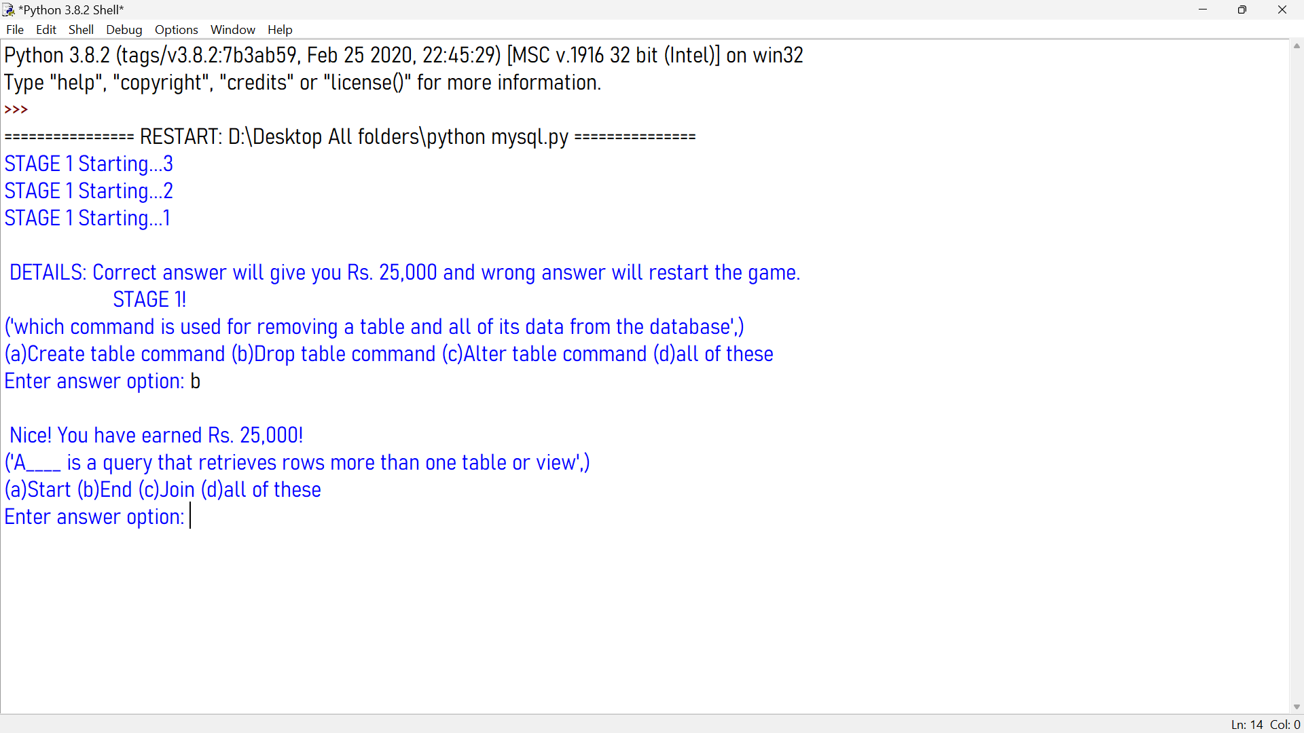

When you get a wrong answer, you get a choice to play again, or to exit:

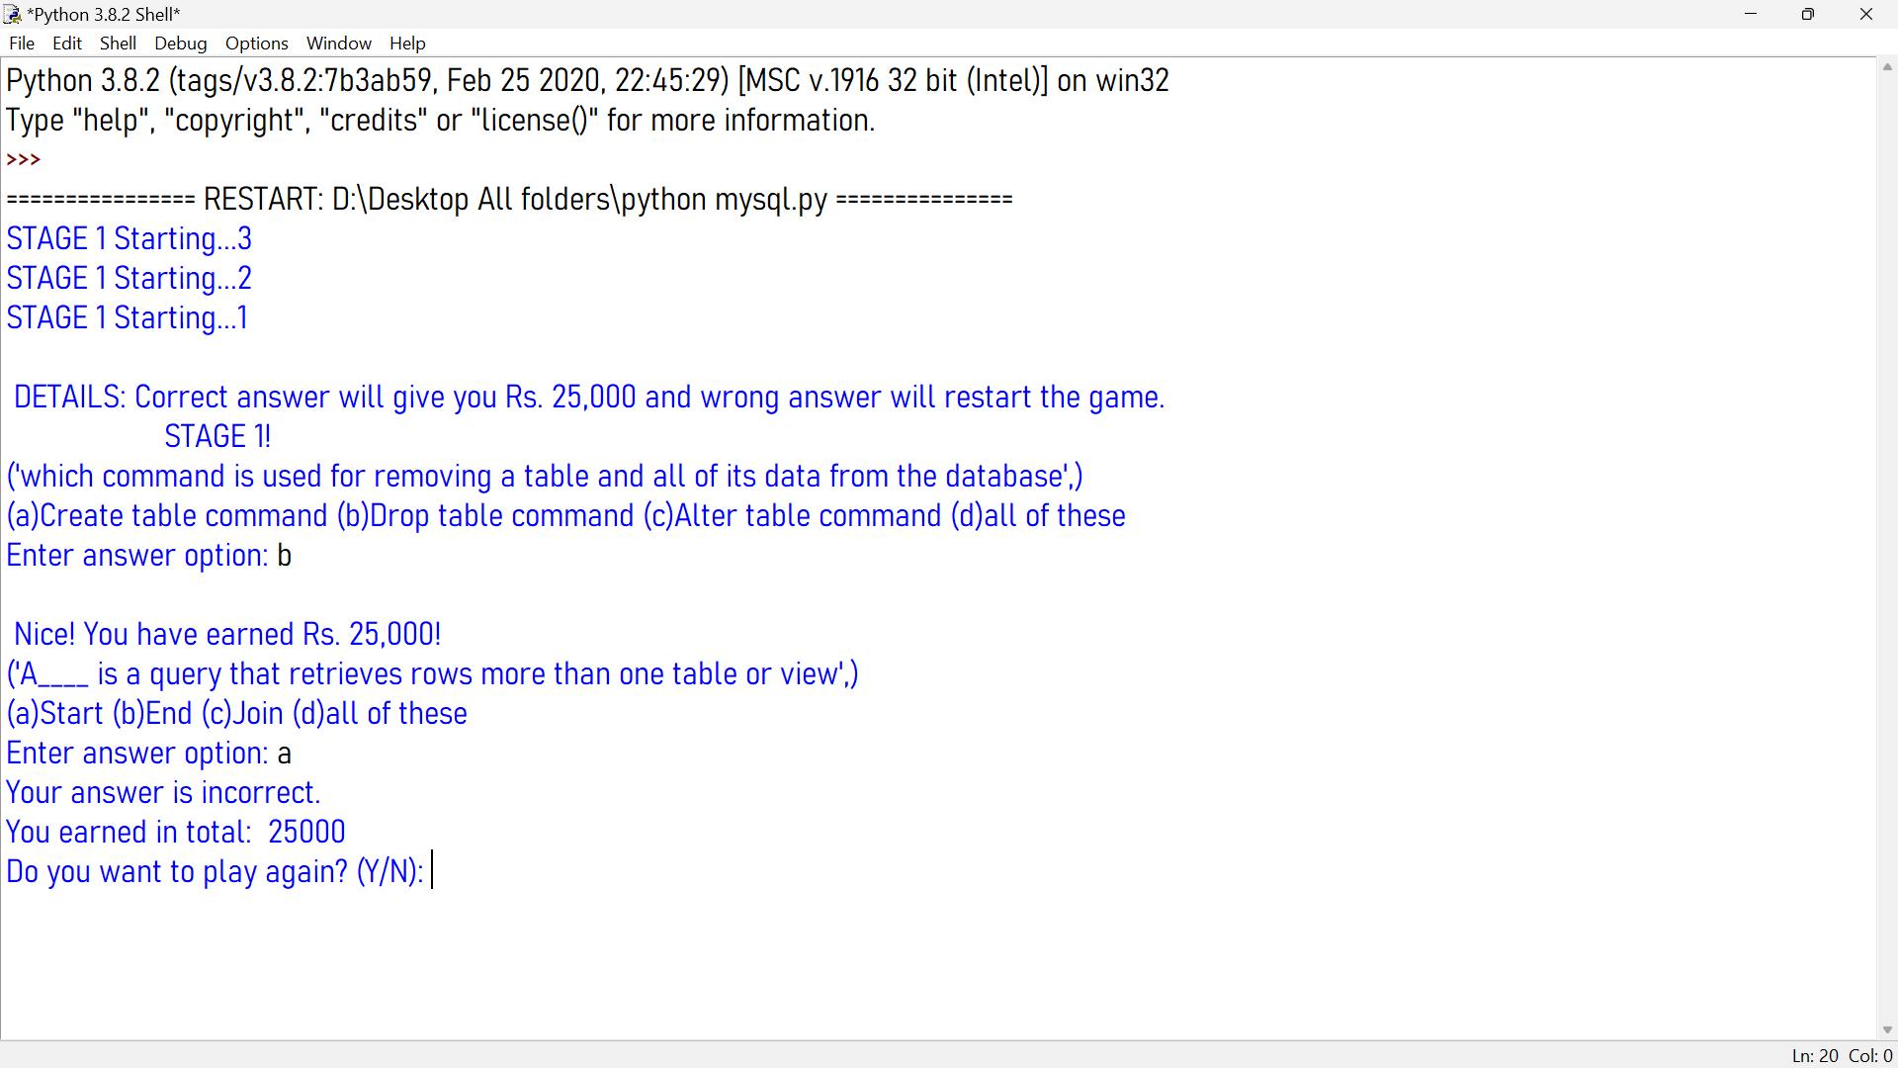

Stage 2 when the user gives 2 correct answers, consecutively in Stage 1. The reward money in Stage 2 is Rs. 50000.

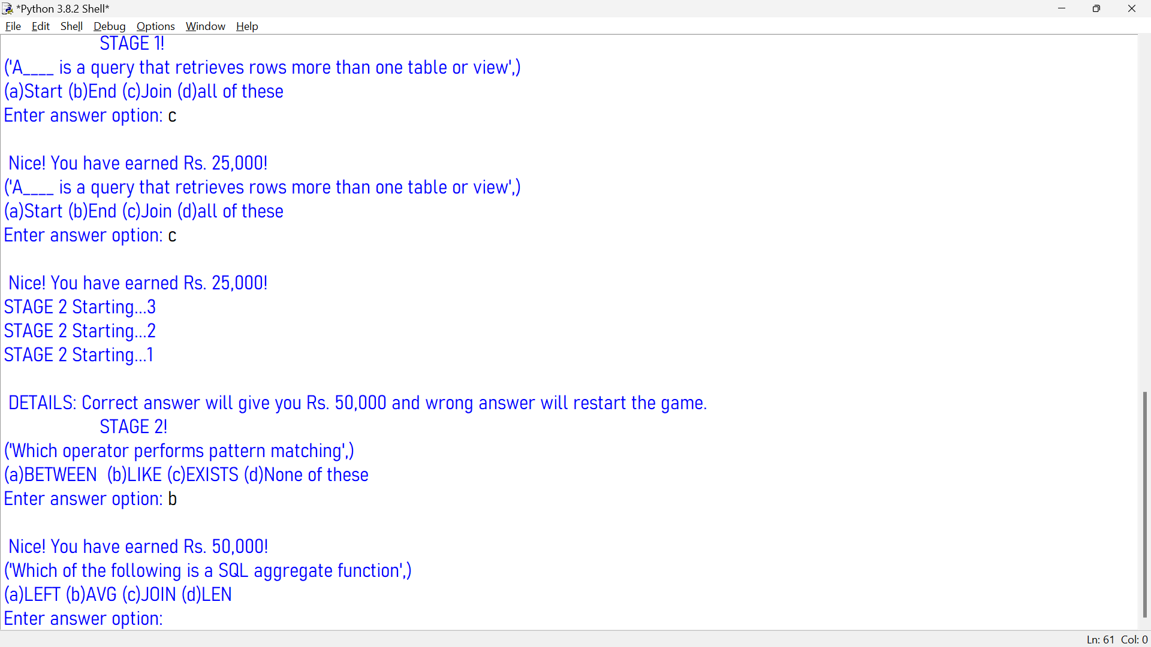

Your total amount is displayed (Stage 1 + Stage 2) is you qualify or lose Stage 2:

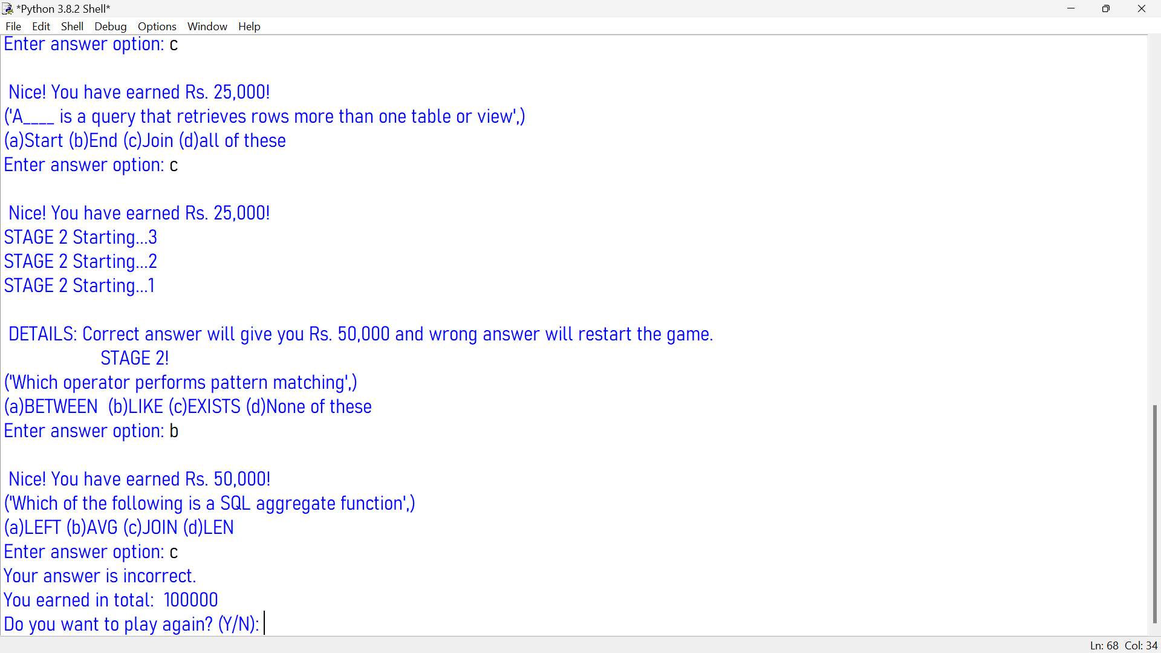

**Bibliography**

* [www.google.com](http://www.google.com) : for details on how to connect MySQL with python and to learn basic concepts on creating database with MySQL.
* Notes from Swati Yadav
* Course Book- Computer Science with Python by Dr.Sumita Arora